COUNCIL ASSESSMENT REPORT
Hunter and Central Coast Planning Panel

PANEL REFERENCE & DA NUMBER | PPS-2019HCC021  DA/2087/2018
PROPOSAL | Subdivision  Two lots into 1079 residential lots, five future development lots, one development lot for a future school, and associated infrastructure including two parks.
ADDRESS | 10, 10C and 144 Woodford Street, Cameron Park  M1 Pacific Motorway, Lake Macquarie  Lot 2 DP 877349, Lot 1 DP 1156243, Part Lot 100 DP 1252590, Lot 22 DP 816113
APPLICANT | Winten (No 21) Pty Ltd
OWNER | Winten (No 21) Pty Ltd  Lake Macquarie City Council  Transport for NSW
DA LODGEMENT DATE | 22 November 2018
APPLICATION TYPE | Development Application
REGIONALLY SIGNIFICANT CRITERIA | Clause 2, Schedule 6 of the Planning Systems SEPP – General development over $30 million
CIV | $116 million (excluding GST)
CLAUSE 4.6 REQUESTS | N/A
KEY SEPP/LEP | Concept Plan MP10_0090 – Minmi, Link Road North and South Residential Development (Northern Estates)
TOTAL & UNIQUE SUBMISSIONS KEY ISSUES IN SUBMISSIONS | Notified:  - 5 December 2018 – 14 January 2019  - 6 October 2020 – 26 October 2020  - 30 July 2021 – 20 August 2021  - 3 June 2022 – 28 June 2022  Council have received eight unique objections.
ATTACHMENTS SUBMITTED FOR CONSIDERATION | - Attachment A: Concept Approval assessment  - Attachment B: Urban Design Guidelines assessment
SPECIAL INFRASTRUCTURE CONTRIBUTIONS (S7.24) | Yes, refer to section 3.5.3
RECOMMENDATION | Defer for resolution of outstanding issues
DRAFT CONDITIONS TO APPLICANT | N/A
SCHEDULED MEETING DATE | 5 December 2022
PREPARED BY | Amy Regado, Section Manager Development
DATE OF REPORT | 28 November 2022

EXECUTIVE SUMMARY
The proposal seeks consent for a subdivision of two into 1079 lots, comprising 1063 residential lots, five future development/residual lots including school site, 16 public/drainage reserves. The application also includes site preparation works including earthworks, clearing of vegetation, contamination remediation and subsidence mitigation works, construction of roads, drainage and utility infrastructure, landscaping to streets, drainage reserves and public reserves and intersection and road network upgrades.
The site forms part of Concept Plan MP10_0090 which was approved by the Planning Assessment Commission in 2013 for a five-stage development of up to 3,300 dwellings and two commercial centres across the 520-hectare site, including associated infrastructure, which straddles the Lake Macquarie City Council and City of Newcastle Local Government Area boundary.
The application relates to a majority of Stage 5 of the Concept Approval.
The application was lodged on 22 November 2018. A deemed refusal appeal was lodged in the Land and Environment Court by the applicant in January 2019. Court proceedings, including conciliation and a hearing occurred throughout 2019, 2020 and 2021 and the proceedings were discontinued by the applicant during hearing in June 2021.
Additional information was lodged to Council for the application in July 2021. The application has continued assessment since this time.
There are several key issues associated with the application including:
- Concept Approval consistency
- Aboriginal heritage
- acoustic impact
- biodiversity
- bushfire protection
- contamination
- earthworks
- mine subsidence
- stormwater management and flooding
- Summerhill Waste Management Centre impacts
- traffic impact
- urban design
- utilities and servicing
Key matters that have been resolved include:
- Aboriginal heritage
- acoustic impact
- bushfire protection
- stormwater management and flooding
- urban design
Key matters that remain unresolved include:
- Concept Approval consistency
- biodiversity
- traffic impact
- earthworks
- contamination
- mine subsidence
- Summerhill Waste Management Centre impacts
- odour impact
- utilities and servicing
The application is recommended to be deferred to enable the submission of further information to address the outstanding matters as identified above.
Alternatively, the application could be refused based upon this matter not being satisfactorily addressed.
- THE SITE AND LOCALITY
  - Site context and locality
The site is located in the suburb of Cameron Park, within the Lake Macquarie City Council (LMCC) local government area (LGA).
The northern boundary of the site adjoins the LGA boundary between LMCC and City of Newcastle (CN). Approximately half of the northern boundary of this site is shared with other lands that are owned by the same developer and are subject to an application for subdivision with CN (DA/20918/01351).
The other main portion of the northern boundary is shared with Blue Gum Hills Regional Park (BGHRP). This Park is administered by the National Parks and Wildlife Service (NPWS). The remaining part of northern boundary is shared with Summerhill Waste Management Centre (SWMC) which is owned and operated by CN.
To the east is a large landholding that was formally owned by a mining company. This land is now owned by a developer and is commonly known as Eden Estates. Both LMCC and CN are in discussions with this developer in regard to rezoning of the land and a significant residential subdivision on this land.
To the west of the site is Woodford Street and Transport for NSW (TfNSW) land holdings. The Cameron Park Drive industrial estate and the Newcastle Link Road / Pacific Motorway interchange are also to the west.
The southern boundary of the site is a ridgeline of which the Newcastle Link Road runs east-west along. The Cameron Park residential estate is located on the southern side of the road, which includes the undeveloped Link Road South development owned by the developer proposing this development.
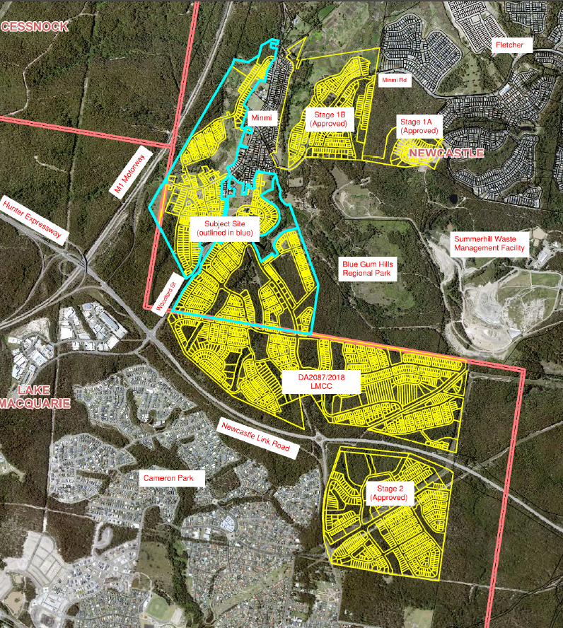
Figure 1: Site context

1.2 Site background
The site forms part of Concept Plan MP10_0090 which was approved by the Planning Assessment Commission in 2013 for a five-stage development of up to 3,300 dwellings and two commercial centres across the 520-hectare site, including associated infrastructure.
The Concept Approval also required the dedication of 1,561 hectares of conservation lands. A Voluntary Planning Agreement (VPA) was entered into with the State Government for the environmental conservation land contribution of the 1,561 hectares. This land was transferred to the State Government in October 2016.
The Concept Approval was modified on 21 December 2016 to adjust the timing of the provision of certain documents.
A second VPA was entered into with the Minister for Planning in 2018 for the provisions of contributions for designated state infrastructure including monetary contribution, dedication of education lands, and dedication of regional open space. Monetary contributions have been paid, and dedication of land will occur as part of the development process.
Consent has been issued for Stage 1 (within CN LGA) known as Link Road South and works have commenced. Stage 2 was approved by the Land and Environment Court (LEC) in December 2017 for 617 lots and works have not commenced as the consent is effectively being held in abeyance pending resolution of traffic matters to satisfaction of TfNSW.
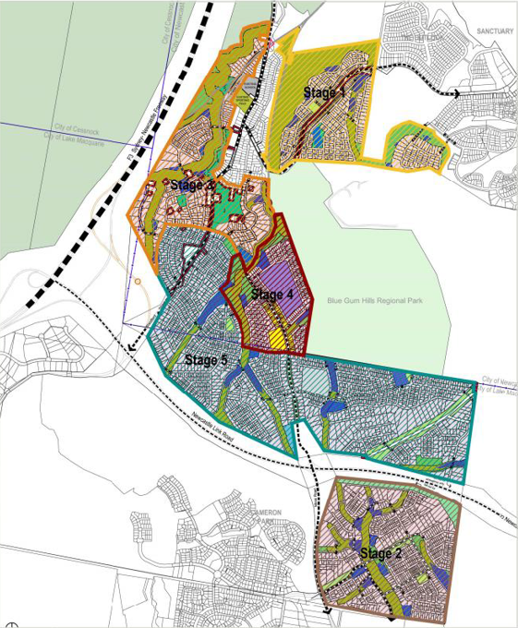
Figure 2: Minmi / Link Road Concept Approval (MP10_0090)
1.3 The site
The site is generally rectangular in shape (approximately 2500m x 800m) with an area of 160 hectares. The land is densely vegetated native bushland, with some cleared areas for fire trails and tracks.
An unformed public road is located in the eastern part of the site, providing a link between Newcastle Link Road and SWMC and the privately owned lands to the east. This connection was previously a Crown Road and was transferred to LMCC as a public road in 2008.
The site is traversed by three overhead transmission lines. An easement on the eastern boundary of the site contains a TransGrid 330KV transmission line. An Ausgrid transmission line is situated within the unformed public road reserve, while the other connects via the road at Newcastle Link Road towards Minmi township.
Topographically, a prominent ridgeline defines the southern boundary, with the site generally falling to the north. The site drains south to north via four main flow paths. The flow paths are ephemeral tributaries of Back Creek. Approximately 20% of the eastern portion of the site drains to the east into Maryland Creek. The higher portions of the site contain slopes over 25%.
The site is bushfire prone from adjacent bushland surrounding the site and from bushland on the site. The site is not flood prone but will experience a level of flooding from on-site ephemeral creek lines.
The site has a history of underground coal mining and is subject to mine subsidence. No surface workings occurred on the site but the site did contain shafts down to underground workings. Some contamination, such as coal chitter contained in fill used to cap shafts and possible debris from a demolished former mine building, remain on the site from those mining operations. Other contamination exists due to opportunistic dumping of household and building waste.
Several Aboriginal sites were identified within the site in 2011 but subsequent attempts to find these sites were unsuccessful and only one site adjacent to the northern boundary remains.
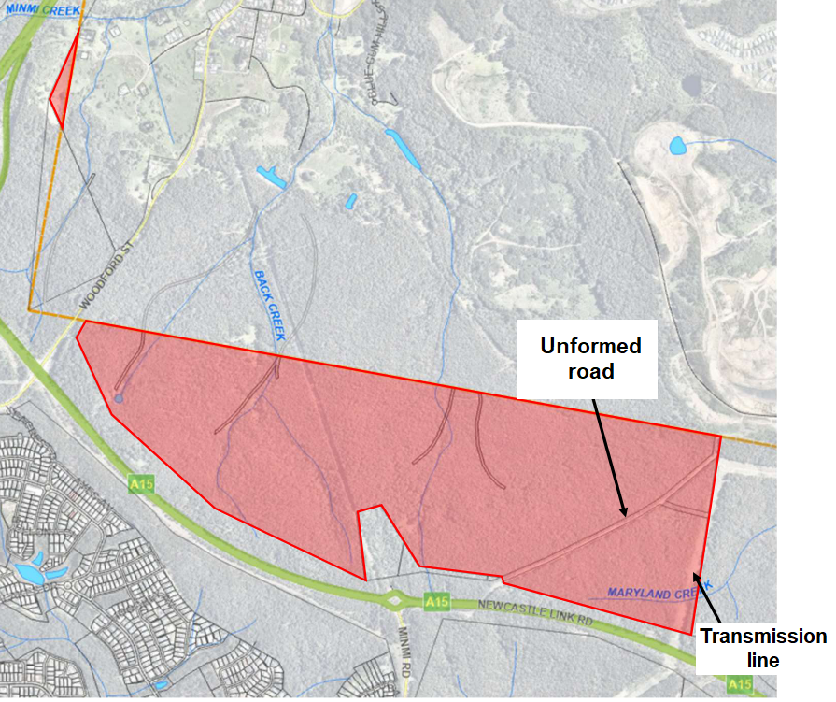
Figure 3: The site

- THE PROPOSAL
  - The proposal
The proposal seeks consent for a subdivision of two into 1079 lots, comprising the following:
- 1063 residential lots
Comprising 944 standard lots ranging from 450m² to 1.9 hectares and 119 small lots ranging between 379m² and 450m².
- 5 future development/residual lots
Lots 1736, 1930 and 4003 are identified for future residential development.
Lot 1201 is split zoned residential/local centre and shares its northern boundary with CN LGA boundary.
Lot 2046 is identified for a potential school site.
- 16 public/drainage reserves
- site preparation works including earthworks, clearing of vegetation, contamination remediation and subsidence mitigation works
- construction of roads, drainage and utility infrastructure
- landscaping to streets, drainage reserves and public reserves
- intersection and road network upgrades.
The development is proposed to be constructed over 21 stages. The stage numbering is not consecutive and some stages may be completed concurrently.
The application relates to a majority of Stage 5 of the Concept Approval.
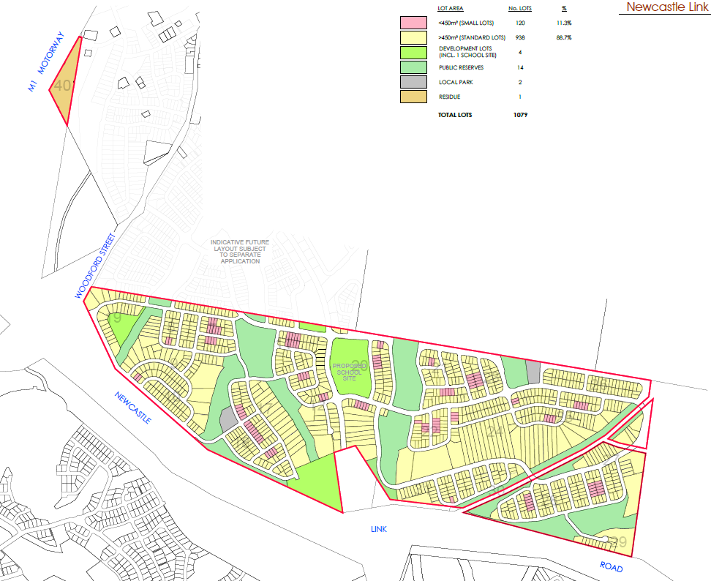
Figure 4: Proposed subdivision

  - Development application
The development application was lodged on 22 November 2018. A chronology of the development application since lodgement is outlined below.
Table 1: Chronology of the DA
Date | Event
22 November 2018 | Lodgement date
5 December 2018 | Exhibition of the application
5 December 2018 | DA referred to external agencies (RFS, TfNSW)
18 January 2019 | Appeal lodged with LEC  Note, CN, TfNSW, NSW RFS, NPWS, and DPIE also joined proceedings
22 February 2019 | DA referred to external agencies (TransGrid, Ausgrid)
23 April 2019 | Satisfactory arrangements certification received from DPIE
21 August 2019 | RPP briefing
30 September 2019 | Section 34 Conferencing commenced  Conferencing held on three separate occasions in 2019 and 2020
31 August 2020 | Section 34 Conferencing terminated
18 May 2021 | Correspondence received from DPIE stating DPIE are satisfied with the locations set aside for recreation facilities
May and June 2021 | LEC Court Hearing scheduled for multiple days in late May / early June.  Appeal withdrawn by applicant in early June
21 July 2021 | Amended plans lodged with Council for development application  Full resubmission of documentation received including updates to reflect discussion held with parties during Section 34 Conferencing
30 July 2021 | Exhibition of the application
30 July 2021 | Referrals to external agencies commenced (TfNSW, RFS, OEH, SA NSW, Ausgrid, TransGrid)
11 August 2021 | RPP briefing
1 December 2021 | RPP site inspection and briefing (joint with CN)
15 March 2022 | RFI issued to applicant
26 April 2022 | RPP briefing
1 June 2022 | Amended plans and documentation lodged with Council
3 June 2022 | Exhibition of the application
June 2022 | DA referred to external agencies (SA NSW, TfNSW)
30 June 2022 | RPP briefing
3 August 2022 | RPP briefing
13 September 2022 | RPP briefing

- STATUTORY CONSIDERATIONS
3.1 Environmental Planning and Assessment Act 1979
When determining a development application, the consent authority must take into consideration the matters outlined in Section 4.15(1) of the Environmental Planning and Assessment Act 1979 (EP&A Act) including:
- the provisions of any environmental planning instrument, proposed instrument, development control plan, planning agreement and the regulations
- the likely impacts of that development, including environmental impacts on both the natural and built environments, and social and economic impacts in the locality,
- the suitability of the site for the development,
- any submissions made in accordance with this Act or the regulations,
- the public interest.
These matters are further considered throughout the report.
3.2 Environmental Planning and Assessment (Savings, Transitional and Other Provisions) Regulation 2017
The development is classified as a transitional Part 3A project in accordance clause 2(1)(b) of Schedule 2 of the Environmental Planning and Assessment (Savings, Transitional and Other Provisions) Regulation 2017 (the Transitional Regulations). Part 3A of the Act, as in force immediately before the repeal of that part, continues to apply to the project in accordance with clause 3(1) of the Transitional Regulations.
Section 3B(2)(d) of Schedule 2 notes a consent authority must not grant consent under Part 4 unless it is satisfied the development is generally consistent with the terms of the approved Concept Plan.
Section 3B(2)(f) of Schedule 2 notes the provision of any environmental planning instrument or development control plan do not have effect to the extent of any inconsistency with the terms of the Concept Approval.
The application has not demonstrated the development is generally consistent with the terms of the approved Concept Plan, and LEP controls, with several matters still requiring resolution.
The application is recommended to be deferred to enable the submission of further information to address the outstanding matters.
3.3 Biodiversity Conservation Act (Savings and Transitional) Regulation 2017
The provisions of clause 34A of the Biodiversity Conservation Act (Savings and Transitional) Regulation 2017 apply to the development and requires consideration of impacts to biodiversity under the former planning provisions, being the Threatened Species Conservation Act 1995 (TSC Act).
Whilst certification under clause 34A(3) of the Savings and Transitional Regulation has been provided, advice has been provided from the Panel Secretariat that the former planning provisions apply and assessment is required to be undertaken to determine whether a species impact statement (SIS) needs to be submitted.
Council’s Ecologist has reviewed the biodiversity reports submitted and identified further information was needed for newly listed species. The applicant was requested to provide this information however has not provided the information as it is their understanding the identified species were not listed under the previous planning provisions and is not subject to an assessment of significance.
Insufficient information has therefore been provided to enable Council and the Panel to assess section 5A of the EPA Act and determine if the development will or will not have a significant effect on threatened species, populations or ecological communities, or their habitats, and whether a SIS is required.
It is recommended the application be deferred to enable the submission of further information to address this matter, as it is resolvable.
Refer to section 4.4 of this report for detailed assessment.
3.4 Provisions of Environmental Planning Instruments - state environmental planning policies
The following state environmental planning policies (SEPPs) are relevant to the application:
- State Environmental Planning Policy (Planning Systems) 2021
- State Environmental Planning Policy (Transport and Infrastructure) 2021
- State Environmental Planning Policy (Biodiversity and Conservation) 2021
- State Environmental Planning Policy (Resilience and Hazards) 2021
A summary of the key matters for consideration arising from these SEPPs is outlined in Table 2 and considered in more detail below.
The majority of SEPPs that apply to the development are consolidated SEPPs which replaced previous SEPPs that applied. The consolidated SEPPs commenced on 1 March 2022. Previous provisions from the repealed SEPPs have been transferred to the consolidated SEPPs, and under section 1.4 of each SEPP it is identified that section 30A of the Interpretation Act 1987 is taken to apply to provisions transferred.
Table 2: Summary of applicable State Environmental Planning Policies
EPI | Matters for consideration | Comply
Planning Systems SEPP 2021 | The development is regionally significant development as per clause 2, Schedule 6 of the Planning Systems SEPP – General development over $30 million. | Y
SEPP Transport and Infrastructure 2021 | Clause 2.122 - traffic-generating development – subdivision of 200 of more residential lots  Referral sent to Transport for NSW who are not satisfied with proposal.  A response from TfNSW in respect to the SEPP has not been received.  It is recommended the application be deferred to enable the submission of further information to address this matter. | N
 | Clause 2.48 – a response to the notice sent to Ausgrid has been received which identifies their requirements for the development, which can be achieved through conditions of consent (upgrading of existing infrastructure to cater for development). | Y
SEPP Biodiversity and Conservation 2021 | Part 3.2 (clauses 3.5 – 3.9) of the SEPP applies as the land is greater than one hectare and an assessment must be made as to whether the land is potential or core koala habitat.  Land was determined to not be core Koala habitat, however further information has been requested to address the up-listing of the species.  The applicant has not provided this information as it is their understanding the identified species were not listed under the previous planning provisions and is not subject to an assessment of significance.  It is recommended the application be deferred to enable the submission of further information to address this matter. | N
SEPP Resilience and Hazards | Clause 4.6 requires (insert) / a Remediation Action Plan and review by a NSW EPA accredited Site Auditor has been submitted, which confirms the land can be made suitable for the proposed residential use with the proposed remediation strategies.  A Remediation Action Plan has been submitted with the application, and does not conclusively identify the location of proposed capping. Insufficient information has been submitted to demonstrate if the site can be made suitable for its intended use.  A request for this information has not been made to the applicant due to the outstanding fundamental site planning and threshold issues. A request for this information can made following the resolution of these fundamental issues, as it is likely the development can achieve this requirement through submission of further information.  It is recommended the application be deferred to enable the submission of further information to address this matter. | N

The development is subject to Schedule 2(3B) of the Transitional Regulations whereby any environmental planning instrument (EPI) provision that is inconsistent with the Concept Approval has no effect, and any requirement for a master plan under an EPI does not restrict the granting of consent.
The majority of the SEPPs that apply to the development are consolidated SEPPs which replaced previous SEPPs that applied. The consolidated SEPPs commenced on 1 March 2022. Previous provisions from the repealed SEPPs have been transferred to the consolidated SEPPs, and under section 1.4 of each SEPP it is identified section 30A of the Interpretation Act 1987 is taken to apply to provisions transferred.
3.4.1 State Environmental Planning Policy (Planning Systems) 2021
The proposal is identified as regionally significant development under clause 2, Schedule 6 of the Planning Systems SEPP – General development over $30 million.
The Hunter and Central Coast Regional Planning Panel are the consent authority for the application.
3.4.2 State Environmental Planning Policy (Transport and Infrastructure) 2021
3.4.2.1 Traffic Generating Development
The development is traffic generating development under clause 2.122 and Schedule 3 of the SEPP, as the application proposes more than 200 residential lots. As traffic generating development, the consent authority is required to give written notice to TfNSW and take into consideration any response.
The application has been referred to Transport for NSW (TfNSW) on several occasions, and TfNSW are not satisfied with the modelling, and therefore the impact of the development cannot be identified.
Refer to section 4.11.3 of this report for detailed assessment.
3.4.2.2 Development likely to affect electricity transmission or distribution network
The development requires the consent authority to give written notice to the electricity supply authority (Ausgrid) before determining the application under clause 2.48 of the SEPP, as the development is within and adjacent to an easement for electricity purposes.
A response has been received from Ausgrid which identifies their requirements for the development, which can be achieved through conditions of consent (upgrading of existing infrastructure to cater for development).
3.4.3 State Environmental Planning Policy (Biodiversity and Conservation) 2021
Part 3.2 (clauses 3.5 – 3.9) of the SEPP applies as land is greater than one hectare and an assessment must be made as to whether the land is potential or core koala habitat.
The biodiversity assessment submitted with the application has undertaken an assessment of koala habitat potential at the site and determined the site to be potential Koala habitat but not core Koala habitat. Further assessment was carried out and determined the site is not core koala habitat as no koalas were observed at the site, and no secondary evidence was found (i.e. scratches on tree trucks, scent markings, scat, tracks in soil, etc).
Council’s Ecologist has reviewed the biodiversity reports submitted and identified further information was needed to assess the recently up-listed species Koala (Phascolarctos cinereus). The applicant was requested to provide this information in June 2022, which was further supported by the Panel in the 30 June 2022 briefing. The applicant has not provided the information.
Insufficient information has therefore been provided to enable Council and the Panel to assess the impact of the development to potential koala habitat. It is recommended the application be deferred to enable the submission of further information to address this matter, as it is resolvable.
Refer to section 4.4.2 of this report for detailed assessment.
3.4.4 State Environmental Planning Policy (Resilience and Hazards) 2021
Clause 4.6 of the SEPP requires the consent authority to consider whether the land is contaminated, and if the land is contaminated, it is satisfied the land is suitable in its contaminated state (or will be suitable, after remediation) for the purpose for which the development is proposed to be carried out.
Assessment of potential contamination has been submitted with the application, including a Remediation Action Plan (RAP). The assessments identify the site contains contamination from historical land uses, illegally dumped waste, and potential for landfill gases emanating from the adjoining SWMC.
The application, via the RAP submitted, proposes to cap and contain contaminated material on-site. The RAP does not conclusively identify the location of proposed capping.
Insufficient information has been submitted to demonstrate if the site can be made suitable for its intended use.
A request for this information has not been made to the applicant due to the outstanding fundamental site planning and threshold issues. A request for this information can made following the resolution of these fundamental issues, as it is likely the development can achieve this requirement through submission of further information.
It is recommended the application be deferred to enable the submission of further information to address this matter.
Refer to section 4.6 of this report for detailed assessment.
3.5 Provisions of Environmental Planning Instruments – local environmental plan - Lake Macquarie Local Environmental Plan 2014
3.5.1 Zoning and permissibility
The site is zoned R2 Low Density Residential, C2 Environmental Conservation, and B2 Local Centre.
The application proposes subdivision, which is permitted with development consent in any zone pursuant to clause 2.6.
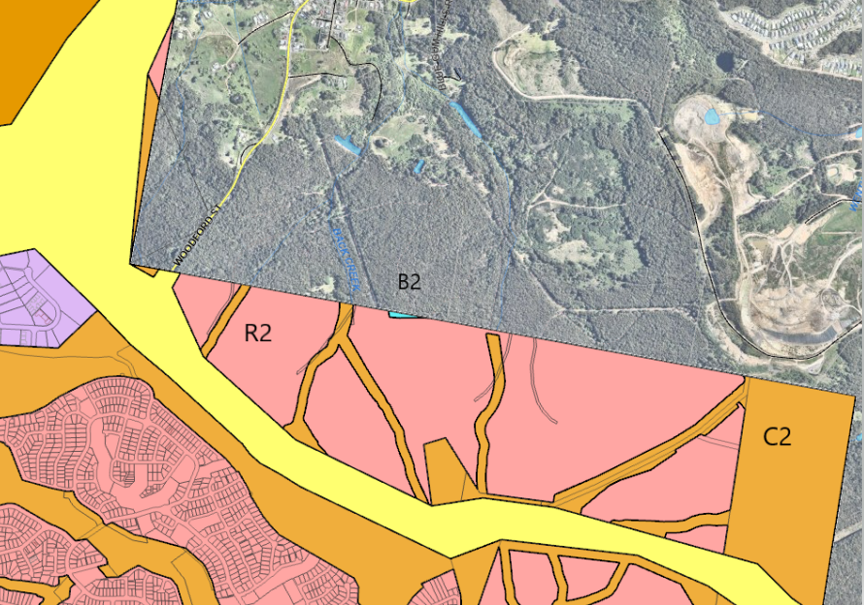
Figure 5: Zoning map extract (R2 shown in pink, C2 shown in brown, and B2 shown in blue)
3.5.2 Minimum subdivision lot size
The minimum lot sizes for each zone, and consideration of the development are detailed in Table 3.
Table 3: Minimum lot size consideration
LEP minimum lot size | Proposed lot size | Comply
Cl 4.1 - R2 zoned land - 450m² | All standard residential lots have a minimum area of 450m² or more. | Y
Cl 4.1B enables subdivision of land that creates 10 or more lots and at least 10% but no more than 50% of those lots to have area equal to or greater than 300m² but not greater than 450m² and be for the purposes of a dwelling house or semi-detached dwelling. | A total of 113 lots (which equates to 10%) are proposed which have areas equal to or greater than 300m² but not greater than 450m². | Y
Cl 4.1C corner lots requires corner lots to have an area of at least 500m² in R2 zone. | All corner lots, except the following meet the minimum corner lot size.  Nine corner lots do not meet the minimum LEP lot size (lots 1710, 1711, 1811, 1812, 1821, 1843, 2438, 3007 and 3138) having areas ranging from 419m² to 497m², however the provisions of an EPI do not have effect to the extent it is inconsistent with the terms of the Concept Plan approval.  As the Concept Plan and subsequent Link Road North Urban Design Guidelines provide minimum lot size controls that permit lots smaller than 450m², clause 4.1 does not have effect in this instance. | N
Cl 4.1C battle-axe lots requires battle-axe lots to have an area of at least 600m² in the R2 zone. | Two battle-axe lots are proposed (Lot 1205 and 2912) which have area of 683m² approximately 1000m². | Y
Cl 4.1D - Exceptions to minimum subdivision lot sizes for certain split zones  C2 zoned land – 40ha | The application proposes to create 13 conservation zoned lots.  Twelve lots do not achieve the minimum lot size and range from 2292m² to 33293m².  Lot 3050 has an area of 41 476m² and achieves the minimum lot size.  All C-zoned lots are for public or drainage reserves.  Subdivision of C2 zone land is permitted as exempt development under Subdivision 38 of the State Environmental Planning Policy (Exempt and Complying Development Codes) 2008.  The SEPP permits the subdivision of land for the purpose of creating a public reserve (including drainage reserves), and no minimum lot size applies.  Whilst the lots do not achieve the prescribed minimum lot size in the C2 zone, the proposed subdivision is permitted as outlined above. | Y
Cl 4.1 - B2 zoned land – no minimum lot size | Lot 1201 has an area of approximately 3600m² which is considered sufficient to provide for its future development for commercial/business. | Y

Part Lot 4003 is located in the LMCC LGA and has an area of 22.572ha. The zone boundary for the lot is not fully understood and includes R2 zoned land, and may include a portion of C2 and SP2 zoned land. This is due to inconsistencies in the cadastral plan and exhibited LEP land use zone maps.
To date, insufficient information has been submitted to enable a detailed assessment of this matter. It is recommended the application be deferred to enable the submission of further information to address this matter.
3.5.3 Arrangements for designed State public infrastructure
Pursuant to clause 6.1, development consent must not be granted for the subdivision of land in an urban release area if the subdivision would create a lot smaller than the minimum lot size permitted on the land immediately before the land became part of an urban release area, unless the Secretary has certified that satisfactory arrangements have been made to contribute to the provision of designated Sate public infrastructure.
Satisfactory arrangements have been received from the Department of Planning and Environment on 23 April 2019.
3.5.4 Public utility infrastructure
Pursuant to clause 6.2, development consent in an urban release area cannot be issued unless the consent authority is satisfied suitable arrangements for public utility infrastructure (water, sewer and electricity).
Public utility infrastructure is available to the development. Refer to section 4.13 of this report for detailed assessment.
3.5.5 Development control plan
Pursuant to clause 6.3, development consent must not be issued for development on land in an urban release area unless a development control plan (DCP) has been prepared for the land.
Urban Design Guidelines (UDG) have been adopted for the development in association with the Concept Approval. These guidelines are the equivalent of a DCP for the site.
All land, except Lot 4003 is subject to the Link Road North Area Plan (the adopted UDG for LMCC). Lot 4003 is subject to the Minmi Precinct Development Guidelines UDG however no controls under the UDG are relevant as the lot is proposed as a future development lot.
The proposal is generally consistent with the UDG, expect for the insufficient information regarding earthworks and fencing to roadway outcomes. Refer to Attachment B for detailed assessment of the UDG.
3.5.6 Earthworks
Pursuant to clause 7.2, development consent is required for earthworks.
The application proposes earthworks across the site for remediation of the site from contamination and mine subsidence, construction of roads, stormwater facilities and utility services, establishment of APZs, regrading to achieve maximum APZ grades, and regrading of residential lots to establish lots suitable for future dwellings. Retaining walls within the site range between 1-5m in height for roads and boundaries. Retaining to residential lots has not been demonstrated, however is discussed in the application documentation.
The extent of earthworks associated with remediation of the site from contamination and mine subsidence is not conclusive.
Further details are required to identify the design, location and set back of retaining walls, particularly where adjoining site boundaries and future public reserves and potential vegetation impacts may arise.
If the application is deferred, a request for this information can be made, as it is likely the development can achieve this requirement through submission of further information.
Refer to section 4.6, 4.7 and 4.8 of this report for detailed assessment.
3.5.7 Flood planning
Pursuant to clause 7.3 (now clause 5.10), development consent must not be granted to land that is flood prone unless the consent authority is satisfied the development is compatible with the flood hazard of the land, will not significantly adversely affect flood behaviour, incorporates appropriate measures to manage risk to life from flood, and not have adverse environmental impacts.
The site is not identified as flood prone, however localised flooding is experienced from catchments within the site.
A flood impact assessment has been submitted with the application which identifies the development will not be adversely impacted by flooding, or cause adverse flooding impacts. The report identifies all residential lots and park lots are located outside of the 100 year flood event, all road crossings are located outside of, or above the 100 year flood level, and safe evacuation is achievable, and stormwater management facilities have been designed to demonstrate peak flows leaving the site to be similar or less than those leaving the site currently during storm events, and not having adverse impacts.
Refer to section 4.9.1 of this report for detailed assessment.
3.5.8 Development on sensitive Aboriginal landscape areas
Pursuant to clause 7.7, for development located on land identified as sensitive Aboriginal landscape area, the consent authority may require an Aboriginal Heritage Impact Statement.
The site maintains one Aboriginal site, which is located in a riparian corridor and proposed to be protected in situ. Documentation addressing impact of the development to Aboriginal cultural heritage has been submitted with the application, demonstrating the development will not have adverse impacts.
Refer to section 4.2 of this report for detailed assessment.
3.5.9 Essential services
Pursuant to clause 7.21, development consent must not be granted to development unless the consent authority is satisfied water, electricity, sewer, stormwater drainage and vehicle access is available or adequate arrangements have been made to make them available.
All essential services are available to the development. Refer to section 4.13 of this report for detailed assessment.
3.6 Provisions of any proposed instruments
There are several instruments, including draft SEPPs that were draft instruments during the assessment period of the application, however have since been adopted.
3.7 Provisions of any Development Control Plan
Ordinarily, the Lake Macquarie Development Control Plan 2014 (LM DCP 2014) would apply, however the Link Road North Area Plan and Minmi Precinct Development Guidelines, which act as UDG, have been adopted for the development in association with the Concept Approval.
A summary of the key matters for consideration arising from the UDG are outlined in Table 3. Refer to Attachment B for detailed assessment of the UDG. Note, no controls under the Minmi Precinct Development Guidelines UDG are relevant to Lot 4003 as the lot is proposed as a future development lot.
Table 4: Summary of UDG controls
Control | Consideration | Comply
Subdivision design and layout | The development includes a layout that is generally consistent with the UDG | Y
Road design | Road design is generally consistent with the UDG | Y
Lot configuration | All lots meet the required minimum area and dimension | Y
Cut and fill | Sufficient information to enable detailed assessment of this matter has not been provided. | N

3.8 Planning agreements under Section 7.4 of the EP&A Act
3.8.1 Concept Approval planning agreement
A planning agreement was entered into under Section 93F (now Section 7.4) of the EP&A Act by the landowners (Winten (No 21) Pty Ltd and Minmi Land Pty Ltd and the State, in September 2018.
The Planning Agreement applies to the entirety of the Minmi Lands covered by the Concept Approval.
The planning agreement provides for a total contribution valued at $18,284,662 (which equates to $81,994 for each hectare of net developable area) and is broken down as follows:
- Monetary Contribution of $519,662 - a monetary contribution paid to the Minister on signing of the planning agreement
- Education contribution of $4,565,000 - the transfer of a new primary school site (Lot 2046) to the Minister or their nominee (valued at $3,200,000), or the payment of a monetary contribution of $3,200,000 in the event the Minister does not require the new primary school site
- Education contribution - the transfer of land to comprise an extension to the existing Minmi Public School of not more than 1.3 hectares (valued at $1,365,000), or the payment of a monetary contribution of $1,365,000 in the event the Minister does not require the school site.
- Environmental offset lands - dedication of 1,561 hectares of conservation lands valued at $13,200,000 that was transferred to the Minister administering the National Parks and Wildlife Act 1974. The land was transferred prior to the signing of the planning agreement).
Obligations of the planning agreement that are still to be fulfilled are:
- Transfer of Lot 2046 for a school site, and land for Minmi Public School extension
Conditions can be imposed requiring evidence these matters have been satisfied prior to the release of the relevant Subdivision Certificate (SC).
For Lot 2046, conditions can be imposed requiring the transfer of the lot prior to the release of the SC that creates the 600th lot.
The Minmi Public School extension is located within the CN LGA and is subject to a separate development application.
3.8.2 Development application proposed planning agreement
The applicant has offered to enter into a draft planning agreement under Section 7.4 of the EP&A Act.
In lieu of monetary contributions under s7.11 the planning agreement proposes:
- Monetary contribution toward the capital cost of constructing sports fields and outdoor courts to meet the demand generated by the LMCC population for this application, with these facilities located in the CN LGA
- Dedication of land to LMCC (or its’ nominee) for the abovementioned sports fields and outdoor courts
- Embellish and dedicate two local parks with playgrounds (being Lots 1851 and 2547)
- Construct and dedicate approximately 800m of shared pathway along proposed MC01
- Provide monetary contribution to be spent on other public works within the LMCC LGA, at LMCC discretion.
A draft planning agreement has recently been prepared by LMCC however has not been provided to the applicant for review, nor exhibited or reported to the elected Council. The agreement has not been provided to the applicant due to the outstanding fundamental site planning and threshold issues. A request for review can be made following the resolution of these fundamental issues, as it is likely an outcome can be achieved for the planning agreement.
It is recommended the application be deferred to enable the submission of further information to address this matter.
3.9 Provisions of Regulations
The Environmental Planning and Assessment Regulation (EPA Reg) contains matters that must be taken into consideration by a consent authority in determining a development application.
No additional matters are relevant to the proposed development.
3.10 Likely impacts of development
The likely impacts of the development, including environmental impacts on both the natural and built environments, and social and economic impacts have been considered as outlined above and the key issues section below.
The likely impacts of the development are not resolved. The application is recommended to be deferred to enable the submission of further information to address the outstanding matters as identified in this report.
3.11 Suitability of the site
The likely impacts of the development, and therefore suitability of the site have not been resolved. The application is recommended to be deferred to enable the submission of further information to address the outstanding matters as identified in this report.
3.12 Public submissions
The proposal was notified in accordance with the Council’s LMDCP 2014 and Council’s Community Participation Plan on the following three occasions:
- 5 December 2018 – 14 January 2019
- 6 October 2020 – 26 October 2020
- 30 July 2021 – 20 August 2021
- 3 June 2022 – 28 June 2022
Eight unique submissions, all in objection to the proposal were received.
Three submissions were received following the first notification period
One submission was received following the second notification period.
Two submissions were received following the third notification period.
One submission was received during the fourth notification period.
One submission was received following the fourth notification period.
The issues raised in these submissions are considered in Table 5.
Table 5: Community submissions
Issue | No of submissions | Council comments
Impact to operations of the Summerhill Waste Management Centre as a regional waste facility. | 3 | Objections have been received from CN regarding the potential impact of the development to the operation of the facility, and particularly the future southern access road which provides an opportunity for a new entry/exit to the facility.  Objections are requesting a suitable buffer is implemented to ensure the future access is not compromised from adjacent residential development.  Objections are requesting a 1000m buffer is implemented to ensure the future operations of the landfill, potentially up to a further 80-130 years, is not comprised from adjacent residential development, odour, acoustic, gas impacts.  The application has demonstrated the development will not be adversely impacted by noise generated from the facility.  Further information is required to demonstrate if odour impacts are acceptable.  The development does not compromise the ability for a future access road to be provided.  Refer to section 4.3.1 and 4.10 of this report for detailed assessment.  The applicant has also provided a detailed response to the submission which addresses how the development has addressed any future access road.
Inconsistency with Concept Approval condition 1.34 | 1 | Objections have been received regarding the interpretation of ‘waste servicing vehicles’ specified in condition 1.34 of the Concept Approval.  The submitter argues the condition caters for up to B-Double sized vehicles.  The submitter argues the condition reference to ‘relevant council’ means City of Newcastle.  Council considers the condition to be satisfied with the collector road network within the subdivision being suitable for waste servicing vehicles.  Refer to section 4.10.2 of this report for detailed assessment.  The applicant has also provided a detailed response to the submission which responds to the submitter’s concerns of heavy vehicles on the key route proposed.
Impact to Blue Gum Hills Regional Park | 2 | Objections have been received from NPWS about impacts of the development, which is adjacent to and upstream to the park.  Specific concerns relate to impacts of earthworks and retaining near the park boundary, and impact to vegetation within the park due to the earthworks, and the vegetation and habitat management plan.  Following submission of additional information, NPWS are satisfied with the latest VHMP.  NPWS remain concerned about impacts of earthworks and retaining near the park boundary, and impact to vegetation within the park due to the earthworks.  It is recommended the application be deferred to enable the submission of further information to address this matter, as it is resolvable.  Refer to section 4.7 of this report for detailed assessment.
Lack of pedestrian and cycle facilities that connect to existing networks | 1 | The development appears to lack pedestrian and cycle facilities that connect to existing networks.  Pedestrian and cycle paths are incorporated throughout the subdivision and provide internal connectivity, as well as connections to BGHRP and other stages of the development.  Refer to section 4.11.3 of this report for detailed assessment.
Lack of public transport network in the development | 1 | The development appears to lack public transport connections.  The internal road network has been designed to accommodate a bus route throughout the estate.  Refer to section 4.11.2 of this report for detailed assessment.

3.13 Agency referrals and concurrence
The development is not integrated development as the terms of the Concept Approval apply.
The Concept Approval requires the following requirements to be met:
- Condition 1.16 – Department of Planning Secretary to be satisfied as to recreation facilities arrangements.
- Condition 1.20 – Office of Environment and Heritage – management procedures for interface to Blue Gum Hills Regional Park and riparian land.
- Condition 1.30 - Subsidence Advisory NSW – requirement for mine subsidence / pothole risk assessment.
- Condition 1.31 – Transport for New South Wales – traffic assessments and intersection upgrades.
- Condition 1.35 – Office of Environment and Heritage – conservation management plan.
- Condition 1.36 – Office of Environment and Heritage – heritage interpretation strategy
- Condition 1.37 – Office of Environment and Heritage – European archaeological investigations.
- Condition 1.38 – Office of Environment and Heritage – Aboriginal heritage management plan.
- Condition 1.45 - NSW Rural Fire Service – requirement for a Bushfire Management Plan to the satisfaction of the RFS.
- Condition 1.47 – TransGrid – requirement to show any requirements in relation to Newcastle – Tomago 330kV transmission line have been met.
The development application has been referred to the various agencies for as outlined below in Table 6. Further details are also included in Attachment A, with respect to the relevant Concept Approval condition.
Table 6: Referrals to agencies
Agency | Referral trigger | Comments | Resolved
Department of Planning Secretary (DPIE) | Condition 1.16 of Concept Plan Approval | Response received from DPIE (May 2021) confirming approving suitable locations for recreational facilities. | Y
Biodiversity and Conservation Division (DPIE) (OEH) | Condition 1.20 of Concept Plan Approval | The application has been referred to OEH (now Biodiversity and Conservation Division (BCD)) for review of the Vegetation Habitat Management Plan (VHMP). BCD raised no objection to the development and recommended some aspects of the VHMP be amended to reflect best practice. The applicant has reviewed these recommendations and provided a response requesting further consideration to times and temperatures for clearing. These matters are resolvable and can be achieved through further consultation with BCD and imposition of appropriate conditions of consent, if the application is deferred. | N
SA NSW | Condition 1.30 of Concept Approval | The application was referred to SA NSW who have requested updated geotechnical assessments in accordance with their current guidelines.  This information has not been provided. | N
TfNSW | Condition 1.31 of Concept Approval | The application has been referred to Transport for NSW (TfNSW) on several occasions, and TfNSW are not satisfied with the modelling, and therefore the impact of the development cannot be identified. | N
 | Clause 104 – Infrastructure SEPP – traffic generating development | A response from TfNSW in respect to the SEPP has not been received. | N
Heritage NSW | Condition 1.35 of Concept Approval | Response received from Heritage NSW confirming they are satisfied with the development, noting the site does not contain any European heritage items, and recommended conditions regarding unexpected finds. | Y
 | Condition 1.36 of Concept Approval
 | Condition 1.37 of Concept Approval
 | Condition 1.38 of Concept Approval | Response received from Heritage NSW confirming they are satisfied with the development, and recommended conditions of consent regarding AHIP applications, if required. | Y
NSW RFS | Condition 1.45 of Concept Approval | The application was referred to NSW RFS who raised no objection to the development and recommended conditions regarding BAL levels, APZs, road construction, utility provision and landscaping. | Y
TransGrid | Condition 1.47 of Concept Approval | The application was referred to TransGrid who raised no objection to the development and recommended conditions regarding construction related matters. | Y

The application was also referred to Ausgrid under clause 2.48 of the Transport and Infrastructure SEPP. Ausgrid raised no objection to the development and recommended conditions for upgrading of existing infrastructure to cater for development.
3.14 Public interest
The likely impacts of the development have not been resolved, and therefore consideration of public interest has not been satisfied. The application is recommended to be deferred to enable the submission of further information to address the outstanding matters as identified in this report.

- KEY ISSUES
The following key issues are relevant to the assessment of this application having considered the relevant planning controls and the proposal in detail.
4.1 Concept Approval
There are several conditions of the Concept Approval that have not been addressed including traffic and access, earthworks, contamination and remediation, mine subsidence mitigation, odour impact, waste servicing, staging plan, vegetation and habitat management plan, landscaping to public domain and fencing, construction environment management plan, and contributions and dedication.
Details of the assessment of the Concept Approval are included in Attachment A.
4.2 Aboriginal heritage
The site maintains one Aboriginal site, which is located in a riparian corridor and proposed to be protected in situ. All other five sites identified during the Concept Approval assessment have since been updated to having been destroyed following multiple attempts to locate the sites in preparation for the application.
Condition 1.36 of the Concept Approval requires a heritage interpretation strategy to be provided that addresses interpretation of Aboriginal heritage throughout the development, including identifying opportunities for long term storage and display of archaeological relics. The strategy is to be prepared in consultation with the Office of Environment and Heritage (OEH) (now Heritage NSW), and Council.
A heritage interpretation plan, prepared by a conservation practitioner has been submitted with the application. The plan includes a detailed history of the whole Concept Approval site and includes Aboriginal heritage interpretation strategies. The application has been referred to OEH (now Heritage NSW) who raised no objection to the development and recommended conditions of consent relating to Aboriginal heritage impact permit (AHIP).
Condition 1.39 of the Concept Approval requires the application to demonstrate all reasonable effort has been made to avoid impacting Aboriginal cultural heritage. Where impacts are unavoidable, requirements for legislative approvals are to be addressed, and mitigation measures are to be negotiated with the local Aboriginal community, and all sites impacted must have an OEH Aboriginal Heritage Site Recording form completed and submitted to OEH within three month of completion of the Aboriginal cultural heritage works.
An Aboriginal cultural heritage management plan (ACHMP) has been submitted with the application, which was undertaken in consultation with the Registered Aboriginal Parties and OEH. The report demonstrates the proposal has been designed to avoid impact to the registered site and recommends works in proximity to the site are avoided. This outcome can be addressed through the imposition of an appropriate condition of consent.
Condition 1.40 requires an Aboriginal Cultural Education Program be developed and implemented in consultation with the local Aboriginal Community, for the induction of all personnel and contractors involved in the construction activities on site, prior to commencement of works. This outcome can be addressed through the imposition of an appropriate condition of consent.
The statement of commitments also requires prior to commencement of works, development of a procurement policy in conjunction with the indigenous community, for works during construction and ongoing maintenance, which incorporates initiatives to encourage local employment opportunities, including Aboriginals for the duration of the project. This outcome can be addressed through the imposition of an appropriate condition of consent.
The statement of commitments also requires prior to commencement of works an Aboriginal heritage plan of management (PoM) to be submitted in accordance with the heritage mitigation measures outlined in the heritage impact statement submitted with the Concept Approval, and include consultation with local Aboriginal stakeholder groups during the preparation of the Cultural Heritage Management Plan (CHMP) and throughout the development program, an updated AHIMS search to ensure all newly identified sites are included, ensure appropriate information, stop work, recording, and corrective action procedures are in place during construction, and implementation of heritage interpretation strategy. This outcome can be addressed through the imposition of an appropriate condition of consent.
It is noted an Aboriginal heritage management plan is already in place for the development, as was required by Condition 1.38 of the Concept Approval prior to the approval of any development application.
  - Acoustic impact
Condition 1.41 of the Concept Approval requires each application to outline strategies for impact of traffic noise on future residents, and restricts the use of acoustic barriers to Newcastle Link Road.
Condition 1.42 of the Concept Approval requires each application to assess the impact of increased traffic noise on all existing residential areas.
The statement of commitments requires an acoustic statement detailing measures to reduce road traffic noise for development along the Newcastle Link Road.
A traffic noise assessment has been submitted with the application. The report considers future residents, as well as the existing residences in the vicinity of the site and details the following acoustic outcomes:
- The majority of future dwellings will not be adversely affected by traffic noise and can achieve relevant internal noise criteria when constructed of standard building materials
- No mitigation is required as a result of traffic noise from the Newcastle Link Road.
- Several lots adjoining Woodford Street and the internal boulevard will exceed the relevant internal noise criteria, as shown in Figure 6.
Lots adjoining Woodford Street and on the eastern side of the internal boulevard are not expected to require acoustic attenuation to future dwellings, as the noise criteria is only exceeded for the rear of these lots where rear setbacks apply.
As a precautionary measure, conditions of consent could be imposed to address any residential building within the affected portion of these lots.
Lots on the western side of the internal boulevard require attenuation features that include:
  - thickened (minimum 4mm) monolithic glass (openable) and standard weather seals (category 1)
  - thickened (minimum 6mm) monolithic glass (openable) and full perimeter acoustic seals (category 2)
  - thickened (minimum 6mm) laminated glass (openable) and full perimeter acoustic seals (category 3)
This outcome can be achieved through the imposition of appropriate conditions of consent requiring a covenant on these lots.
- Noise assessment of existing traffic volumes identifies exceedance of the relevant noise criteria to existing residents for day and night periods. Traffic generated by the development will not increase existing levels by more than 12dB, which is consistent with the relevant noise policy for both day and night assessment periods, and no noise mitigation to existing residences is required.
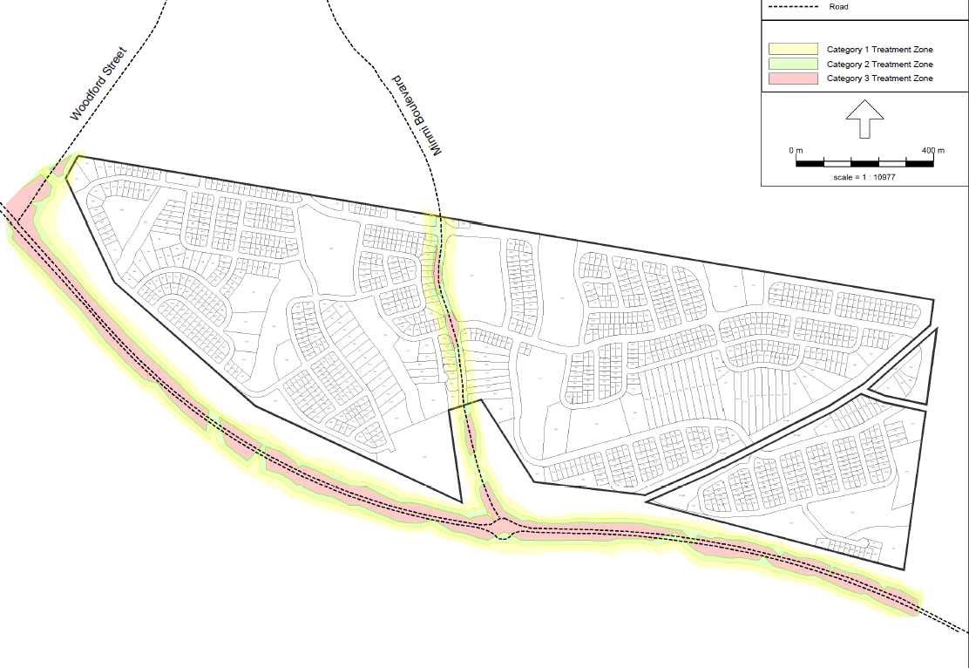
Figure 6: Acoustic attenuation plan
4.3.1 Summerhill Waste Management Centre acoustic impact
An acoustic assessment has been submitted with the application that addresses potential noise from the adjoining SWMC (i.e. reverse alarms, truck and plant movement within the facility). The report identified the measured noise was below the default Noise Policy for Industry (NPI) criteria. No mitigation measures are required to attenuate noise generated by the SWMC.
Objections have been received from CN requesting a suitable buffer (1000m is suggested) to ensure the SWMC is not compromised from adjacent residential development. The assessment demonstrates no mitigation measures are required.
4.4 Biodiversity
Following approval of the Concept Approval, the Department of Planning Industry and Environment (DPIE) (now Department of Planning and Environment) provided certification in 2019 under clause 34A(3) of the Biodiversity Conservation (Savings and Transitional) Regulation 2017 certifying the development has appropriately considered and mitigated biodiversity impacts associated with the development up until 25 August 2017.
During the assessment of the development application, advice in relation to the s34A(3) Biodiversity Certification was provided from the Panel Secretariat regarding the extent of further flora and fauna investigation to meet the legislative framework. The advice confirmed Part 4, including former sections 5A, 78A, 79B and 79C, of the EP&A Act applies and assessment is required to be undertaken to determine whether a SIS needs to be submitted. In applying 5A of the EP&A Act, the consent authority must consider not only the factors under that section but also the VPA (dedication of 1,561 hectares of conservation lands) and the conditions of the Concept Plan Approval.
The application proposes to clear approximately 150 hectares of vegetation, minus vegetation within riparian corridors zoned conservation, and retain vegetation on lands with steeper slope. Clearing is primarily as a result of earthworks for construction of roads, stormwater facilities and utility services, establishment of APZs, regrading to achieve maximum APZ grades, and regrading of residential lots to establish lots suitable for future dwellings. Where APZs do not require regrading, selective thinning will occur to enable vegetation to be retained within residential lots.
Council’s Ecologist has reviewed the biodiversity reports submitted and identified further information was needed for species listed under the Threatened Species Conservation Act 1995 after the s34A date, which includes Rhodamnia rubescens (Scrub Turpentine) and recently up-listed species Koala (Phascolarctos cinereus).
The applicant was requested to provide this information in June 2022, which was further supported by the Panel in the 30 June 2022 briefing. The applicant has not provided the information as it is their understanding the identified species were not listed under the previous planning provisions and is not subject to an assessment of significance.
Insufficient information has therefore been provided to enable Council and the Panel to assess section 5A of the EPA Act and determine if the development will or will not have a significant effect on threatened species, populations or ecological communities, or their habitats, and whether a SIS is required.
It is recommended the application be deferred to enable the submission of further information to address this matter, as it is resolvable.
4.4.1 Concept Approval condition 1.20 and statement of commitments
Condition 1.20 of the Concept Approval requires each application to include details of strategies to avoid and minimise clearing and disturbance of vegetation where possible, management measures for minimising impacts on fauna during subdivision works including the implementation of appropriate tree clearing protocols, details regarding the management of the interface between the site and the conservation lands, Blue Gum Hills Regional Park and riparian land, with management procedures to be prepared in consultation with OEH and be carried into a VHMP.
The statement of commitments also requires trees of significance and trees within riparian corridors to be protected, wherever feasible.
The application has minimised clearing and disturbance of vegetation, to the extent possible, and proposes to retain vegetation within riparian corridors zoned conservation, and retain vegetation on lands with steeper slope. Clearing is primarily as a result of earthworks for construction of roads, stormwater facilities and utility services, establishment of APZs, regrading to achieve maximum APZ grades, and regrading of residential lots to establish lots suitable for future dwellings. Where APZs do not require regrading, selective thinning will occur to enable vegetation to be retained within residential lots.
The application has been referred to OEH (now Biodiversity and Conservation Division (BCD)) who raised no objection to the development and recommended some aspects of the VHMP be amended to reflect best practice. The applicant has reviewed these recommendations and provided a response requesting further consideration to times and temperatures for clearing. These matters are resolvable and can be achieved through further consultation with BCD and imposition of appropriate conditions of consent, if the application is deferred.
The statement of commitments requires prior to any works on site commencing, a VHMP is to be implemented requiring direction and supervision be provided by suitably qualified persons associated with vegetation removal, recovery of any native fauna that are potentially displaced, clearing protocol, selection of species to locally occurring native species for future landscaping works and seed stock for revegetation, completion of earthworks and works in the vicinity of drainage lines undertaken during appropriate weather conditions to minimise potential erosion impacts, and implementation of nutrient and sediment control devices. This outcome can be addressed through the imposition of an appropriate condition of consent.
4.4.2 State Environmental Planning Policy (Biodiversity and Conservation) 2021 - Koala habitat
Part 3.2 (clauses 3.5 – 3.9) of the SEPP applies as the land is greater than one hectare and an assessment must be made as to whether the land is potential or core koala habitat.
The biodiversity assessment submitted with the application has undertaken an assessment of potential koala habitat at the site. The assessment identified the site comprises potential koala habitat due to the presence of feed tree species.
Further assessment was carried out and determined the site is not core koala habitat as no koalas were observed at the site, and no secondary evidence was found (i.e. scratches on tree trucks, scent markings, scat, tracks in soil, etc).
Council’s Ecologist has reviewed the biodiversity reports submitted and identified further information was needed to assess the recently up-listed species Koala (Phascolarctos cinereus).
The applicant was requested to provide this information in June 2022, which was further supported by the Panel in the 30 June 2022 briefing. The applicant has not provided the information.
Insufficient information has therefore been provided to enable Council and the Panel to assess the impact of the development to potential koala habitat. It is recommended the application be deferred to enable the submission of further information to address this matter, as it is resolvable.
4.5 Bushfire protection
Condition 1.45 of the Concept Approval requires a bushfire management plan to be submitted that demonstrates the development complies with the Planning for Bush Fire Protection 2006 (PBP) and to the satisfaction of the NSW Rural Fire Service (RFS), and provides detailed arrangements for a road network and lot layout appropriate to evacuation purposes, property access roads which allow for the safe access, egress and defendable spaces for emergency services, location and composition of all Asset Protection Zones (APZs), ongoing maintenance requirements for APZs, fire trails and access tracks, and staged approach to management of bushfire hazard and APZs during the development process.
A bushfire assessment in the form of a bushfire management plan has been submitted with the application. The report details the following range of bushfire protection measures to be included in the subdivision:
- Perimeter roads throughout the subdivision, connections to existing fire trail network, and road network design that provides for defendable spaces, evacuation and safe access/egress
- Provision of APZs within residential lots or within the road reserve.
APZs within residential lots will be identified on title through an appropriate easement. Where lots contain an APZ, the lots have been designed to ensure an adequate building envelope can be achieved.
No APZs are located on lands to be dedicated to Council for reserve purposes.
- Access to reticulated water supply, including fire hydrants
- Subdivision Building Attack Level (BAL) plan detailing the specific layout and protection measures for future development on the lots
- Strategically designed planting palette for public domain areas containing a combination of fire-resistant species.
- An APZ soil stability management plan has been submitted to demonstrate APZs in escarpment areas or on slopes greater than 15 degrees, can be treated and maintained safely and without compromising slope stability
- Temporary APZs will be provided during construction of the development over the proposed stages comprising a 100m buffer
The application, including bushfire management plan was referred to the NSW RFS who support the proposal and recommended conditions in relation to BALs, APZs, road and fire trail construction, utility provision, and landscaping.
In accordance with clause 273B of the EPA Reg 2000, PBP remains the relevant prescribed document for all development applications made (but not determined) before 1 March 2020. The RFS have acknowledged this in their response to the application.
The statement of commitments also requires a bushfire management plan prior to works commencing for each stage and be certified by a qualified consultant as complying with PBP and any requirements of the RFS. The plan is to address location of APZs (permanent and temporary), road and access design, building construction levels, location of habitat trees to be retained, areas of vegetation to be removed, retained or replaced, access to services and utilities, plant species, and preparation of fuel management plan. These matters have been assessed (i.e. APZs) or can be addressed through the imposition of an appropriate condition of consent.
4.6 Contamination
Clause 4.6 of the State Environmental Planning Policy (Resilience and Hazards) 2021 requires the consent authority to consider whether the land is contaminated, and if the land is contaminated, it is satisfied the land is suitable in its contaminated state (or will be suitable, after remediation) for the purpose for which the development is proposed to be carried out.
Condition 1.29 of the Concept Approval requires a remediation action plan to be provided with each subdivision development application which includes characterisation of the nature and extent of contaminated material within the subdivision area, details of the remediation strategy and management measures to ensure the land is suitable for the proposed land use, a validation plan, details of compliance with the Contaminated Land Management Act 1997.
Three assessments relating to contamination have been undertaken and submitted with the application including:
- Preliminary Contamination Assessment (PCA) (assessed the entire Concept Approval) in 2011
- Detailed Contamination Assessment (DCA) (assessed the LMCC site) in 2018
- Remediation Action Plan (RAP) (assessed the LMCC site) in 2022, including validation plan
This assessments identify the following contamination on the land:
- Importation and use of fill of unknown origin or quality fill mounds and around mine shafts
- Illegally dumped waste, including asbestos containing material
- Potential use of hazardous building materials and potential storage and use of fuels and oils around former mine infrastructure
- Potential for landfill gases emanating from SWMC
The 2022 RAP identifies the volume of contaminated material to be approximately 2000/3000m³ comprising 750m³ fill material from former mine areas, 50m³ mounded fill areas, 110m² historic mining activity and 1000m³ likely unexpected finds.
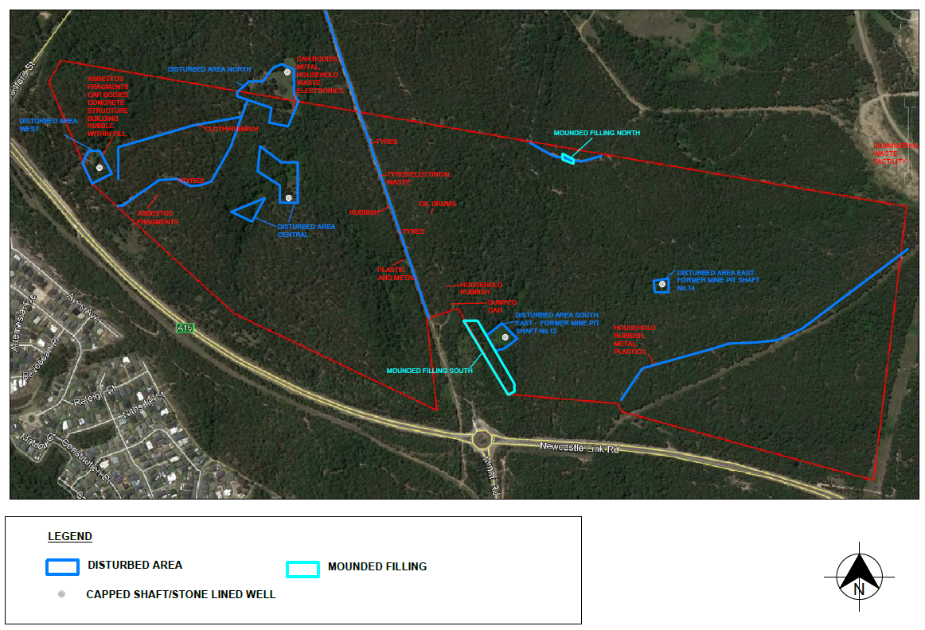
Figure 7: Location of contamination
The proposed remediation strategy is to cap and contain contaminated material on-site at depths greater than 2m or greater than 5m, depending on the categorisation of the contaminated material.
Where material is capped at less than 5m depth, a long term environmental management plan will be required and notations will be required to be included on the property’s planning certificate. This outcome can be addressed through the imposition of an appropriate condition of consent.
The RAP has not conclusively identified the location of capping, and suggests the commercially zoned land, or underneath road MC 58 as possible locations.
Whilst the RAP indicates the land can be made suitable for residential use following remediation, sufficient information has not been submitted to demonstrate this. A request for this information has not been made to the applicant due to the outstanding fundamental site planning and threshold issues. A request for this information can made following the resolution of these fundamental issues, as it is likely the development can achieve this requirement through submission of further information.
The RAP also incorporated an asbestos management plan. Council’s Environmental Management Officer has reviewed the plan and identified further information is required to be included in the plan (i.e. keeping of log, updating plan as asbestos is removed, etc). These matters can be addressed through the imposition of an appropriate condition of consent and submission prior to the issue of the Construction Certificate (CC).
The statement of commitments also requires prior to the issue of the SC for each stage detailed contamination assessment, a remediation action plan verified through the site auditor process, remediation conducted to remove identified contaminants, removal of deleterious materials, validation testing and verification, and waste classification of any materials disposed off-site. These matters can be addressed through the imposition of an appropriate condition of consent.
It is recommended the application be deferred to enable the submission of further information, as detailed above.
4.7 Earthworks
Condition 1.14 of the Concept Approval requires lots on land with greater than 25% slope to have an adequate area for a dwelling to be constructed on land which is not greater than 25% slope, and that vehicular access to the dwelling can be provided at a grade of not greater than 25%, and all lots on land with slope greater than 20% are at least 1,000m² in area.
The Lake Macquarie Local Environmental Plan 2014 (LM LEP) requires consideration to be given to the likely impact of earthworks to drainage patterns and soil stability in the locality of the development, the effect of the development on the future use of the land and adjoining properties, the source and quality of fill, impacts to environmentally and cultural areas, and measures to mitigate impacts.
The UDG requires cut and fill to be responsive to the design constraints associated with the site topography. The UDG acknowledges significant earthworks will be required to accommodate required subdivision works including roads, drainage, detention basins and utility infrastructure.
The application proposes earthworks across the site for remediation of the site from contamination and mine subsidence, construction of roads, stormwater facilities and utility services, establishment of APZs, regrading to achieve maximum APZ grades, and regrading of residential lots to establish lots suitable for future dwellings. Retaining walls within the site range between 1-5m in height for roads and boundaries. Retaining to residential lots has not been demonstrated, however is discussed in the application documentation.
Further details are required to identify the design, location and set back of retaining walls, particularly where adjoining site boundaries and future public reserves and potential vegetation impacts may arise. NPWS, as the adjoining land owner of BGHRP, have also provided submissions to the impact of earthworks and retaining near the park boundary, and potential impact to vegetation within the park due to the earthworks.
Sufficient information to enable detailed assessment of this matter has not been provided, including resultant residential lot slopes, and impacts to vegetation to adjoining land and BGHRP. A request for this information has not been made to the applicant due to the outstanding fundamental site planning and threshold issues. A request for this information can be made following the resolution of these fundamental issues, as it is likely the development can achieve this requirement through existing site design or incorporation of measures such as retaining walls (designed and located appropriately).
It is recommended the application be deferred to enable the submission of further information to address this matter, as it is resolvable.
4.8 Mine subsidence
Stage 5 of the development comprises areas identified as having limited, moderate and high subsidence risks. The site does not contain any pothole risk areas.
Three capped mine shafts have been identified on-site. Two of the mine shafts are proposed within residential lots (Lot 1913 and 2458) and the third mine shaft is proposed within land a public reserve (Lot 3146). The residential lots containing the capped mine shafts have been created as larger lots to enable suitable building areas to still be available on them. Covenants will also be placed on these lots to identify the shafts and restrictions on building.
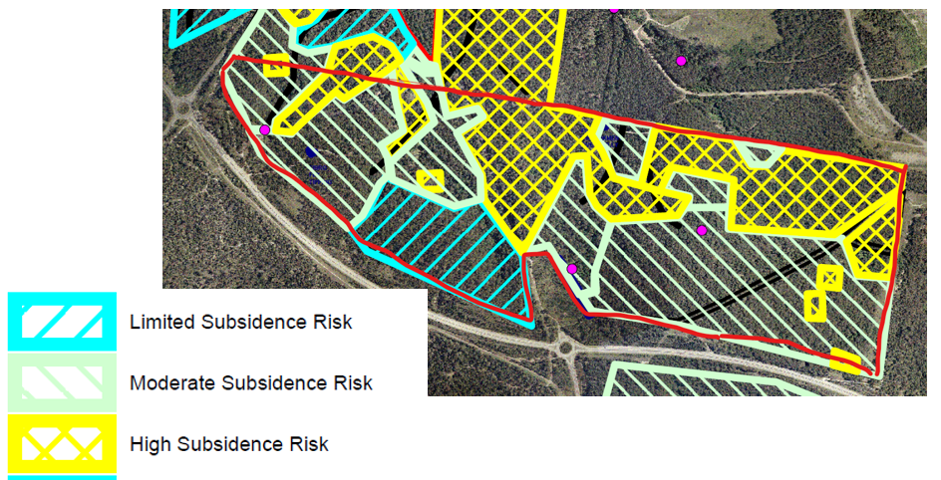
Figure 8: Mine subsidence risk mapping (capped mine shafts shown by purple dot)
Condition 1.30 of the Concept Approval requires geotechnical investigations to be submitted prior to issuing of any subdivision certificate, in accordance with the Mine Subsidence Board requirements (now Subsidence Advisory NSW (SA NSW)) to demonstrate the risk of mine subsidence can be removed and / or managed within the development site by suitable means, or demonstrate that the works are long term stable and there is no risk of subsidence, as appropriate to the intended future use of the land.
The statement of commitments requires additional investigations to address pothole risk, grouting, and depth of covering to workings, and ongoing consultation with SA NSW for each stage and/or lot.
Due to the potential impacts arising from these works and the final site layout and environmental outcomes, consideration of this matter is required to be undertaken and resolved during the assessment of the application.
The application proposes to manage subsidence risk through building design restrictions. No grouting works are proposed. The applicant proposes to address the requirements of Condition 1.30 at SC stage.
The application was referred to SA NSW who have requested additional information be provided in order to assess the risk of mine subsidence at the site. SA NSW have identified the geotechnical reports submitted have been prepared prior to the current SA NSW subdivision assessment policy, and SA NSW have requested updated geotechnical assessments that reflect the requirements of the current policy. Due to the presence of mine openings and areas affected by shallow workings, SA NSW’s current policy requires the subsidence hazard to be eliminated, and sufficient information to demonstrate this has not been provided.
Additional information was submitted to Council in late September, that did not include updated geotechnical assessment to address SA NSW’s request. This information has not been re-referred to SA NSW due to the outstanding fundamental site planning and threshold issues, and limited change in information submitted. A request for this information / re-referral can made following the resolution of the other fundamental issues, as mine subsidence risk mitigation is a resolvable issue.
The statement of commitments also requires restrictions on building height and construction, management of land containing shafts, plan of management for shallow mined areas, and detailed road design. These matters can be addressed through the imposition of an appropriate condition of consent.
4.9 Stormwater management and flooding
Condition 1.25 of the Concept Approval requires a water sensitive urban design (WSUD) strategy to be provided to consider how impacts from stormwater infrastructure are minimised on riparian corridors and waterways. The strategy is to be a strategic level document and demonstrate where possible stormwater infrastructure will be located off-line and outside of the identified riparian corridor (having regard for relevant NSW Office of Water guidelines relating to works within riparian corridors).
A WSUD strategy has been submitted with the application. The report provides guidance to inform the layout of the development to minimise impacts to the riparian corridors, design and location of permanent stormwater management facilities, guidance on mitigation of flooding impacts as a result of the development, and guidance on the design of temporary erosion and sedimentation during construction.
The NSW Office of Water guidelines recommend an average 10m vegetated riparian zone (VRZ) for 1st order watercourses and 20m for 2nd order watercourses. The site contains 1st and 2nd order watercourses, all of which are located within the conservation zoned land. Works such as road crossings and stormwater facilities, including basins are permitted in VRZs.
The application proposes to protect watercourses by:
- minimising the number of road crossings over watercourses, and inclusion of retaining walls (instead of batters) to road crossings
- including widened conservation corridors to include adjacent residential land to ensure earthworks and APZs do not impact the VRZ and conservation zoned lands where watercourses are located
- locating stormwater management facilities off-line from the adjacent watercourse.
Condition 1.26 of the Concept Approval requires detailed design that is consistent with Council’s requirements and the WSUD strategy for stormwater management infrastructure and devices. The statement of commitments also requires, as relevant, preparation of a groundwater management strategy and maintenance regime, lot detention for housing lots, mosquito risk and management assessment.
A stormwater management plan and associated civil engineering plans have been submitted with the application, which incorporates the WSUD strategy and provides detailed analysis to inform the sizing and design of stormwater management facilities throughout the development, including pit and pipe network throughout the subdivision, future rainwater tanks to residential lots, gross pollutant traps, infiltration systems and bioretention basins. The report demonstrates the range of stormwater management facilities will mitigate the impact of the quality and quantity of stormwater runoff from the development to levels that are consistent with Council’s guidelines and industry standards.
The mosquito risk and management assessment is not relevant to the LMCC application.
Condition 1.27 of the Concept Approval requires management arrangements to be provided for public stormwater facilities, during and after construction, prior to being dedicated to the relevant Council.
The statement of commitments also requires details on the proposed bio-retention basins, bio swales and swales, maintenance program for bio-swales, public stormwater system/basins, and transfer program to be submitted with the CC application.
The stormwater management plan and associated civil engineering plans provide details of the stormwater management facilities, which are consistent with Council’s requirements. Council has standard conditions and management guidelines to ensure facilities to be dedicated are constructed and managed appropriately and will be acceptable as public assets after the initial maintenance period. These matters can be addressed through the imposition of an appropriate condition of consent.
4.9.1 Flooding
The site is not identified as flood prone, however localised flooding is experienced from catchments within the site.
Condition 1.23 and 1.24 of the Concept Approval requires the application to include flood modelling which addresses terrain information (i.e. digital elevation model), identifies any flooding effects associated with the Hunter River and ocean levels including any impacts associated with sea level rise, consideration of impacts on climate change on flood hazard, consideration of flooding impacts associated with the proposed development, and each lot can accommodate dwellings located above the flood planning level (100 year flood plus 0.5 metre free board with fill limited to the 0.5 metre free board only), safe evacuation can be provided from all dwellings and public land below the probable maximum flood level, through consultation with the relevant Council and State Emergency.
The statement of commitments also requires stormwater management measures to be included to manage flood risk according to the NSW Floodplain Development Manual.
A flood impact assessment has been submitted with the application. The report identifies all residential lots and park lots are located outside of the 100 year flood event. Only the public reserves containing watercourse corridors are impacted by the flood event. All road crossings are located outside of, or above the 100 year flood level, and safe evacuation is achievable.
The assessment also demonstrates the development will result in the peak flows leaving the site to be similar or less than those leaving the site currently during storm events, due to the design of the stormwater management facilities.
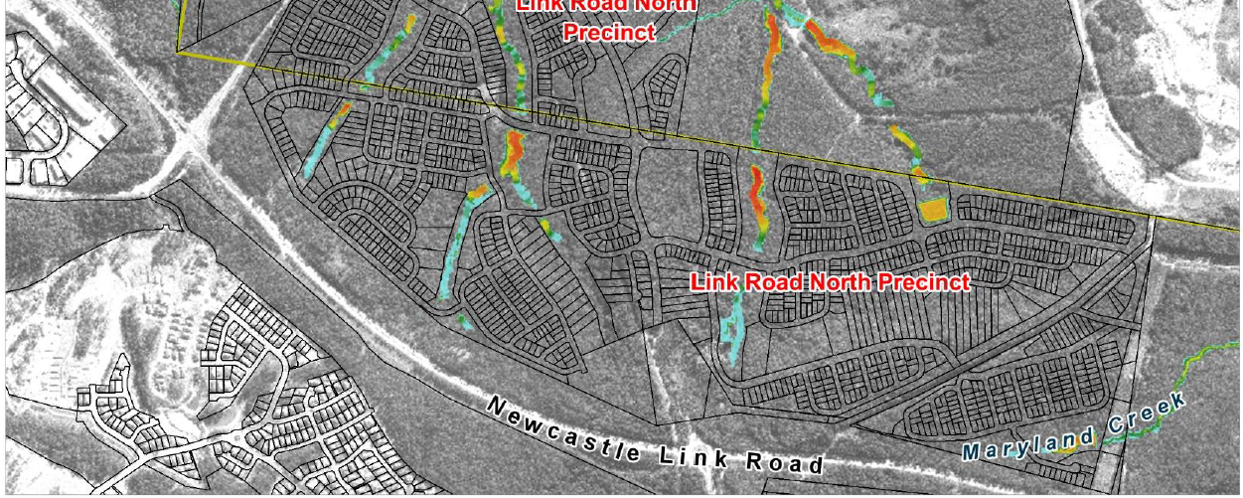
Figure 9: Extent of flood inundation during 100 year flood event (post development)
4.10 Summerhill Waste Management Centre
4.10.1 Odour impacts
Concept Approval condition 1.44 requires each development application for subdivision to consider odour impacts associated with the SWMC, and identify appropriate mitigation measures to manage these impacts.
Objections have also been received from CN requesting a suitable buffer (1000m is suggested) to ensure the SWMC is not compromised from adjacent residential development.
An odour assessment has been submitted with the application. The report identified the following:
- observed odour associated with the SWMC to be 255m from the boundary
- the Environmental Impact Statement for SWMC requires a minimum 400m buffer between on-site potentially odour generating activities and sensitive land uses, with the retention of the vegetated buffer zone. The facility currently has an active landfill cell closer than 400m to the boundary of the subdivision site
- 430m buffer from an active cell/s would be sufficient to mitigate the potential for odour at the boundary of the subdivision site.
Council’s Environmental Systems Officer has reviewed the report and identified further information is needed to confirm the recommended 430m buffer zone will address odour impacts from the SWMC. This includes further assessment in different climatic conditions and times of day, and assessment of all waste activities undertaken at the site.
Should the 430m buffer be confirmed, conditions of consent would be needed to ensure the subdivision staging is constructed to ensure the buffer is maintained.
Insufficient information has therefore been provided to enable Council and the Panel to assess the potential odour impacts from SWMC to the development, and any mitigation measures required.
It is recommended the application be deferred to enable the submission of further information to address this matter, as it is resolvable.

4.10.2 Concept Approval condition 1.34
Condition 1.34 of the Concept Approval requires the application to demonstrate that key roads linking Minmi Boulevard and the waste management centre have been designed to accommodate waste removal vehicles in accordance with any requirements of the relevant Council, unless otherwise agreed to by that Council.
Objections have been received from CN regarding the interpretation of ‘waste servicing vehicles’ specified in condition 1.34 of the Concept Approval. CN argue the condition caters for up to B-Double sized vehicles, which could not be accommodated within the subdivision road network.
CN also argue the condition reference to ‘relevant council’ means City of Newcastle.
The applicant proposes to satisfy the condition as follows:
- Road MC58 is the key road that links Minmi Boulevard (Road MC01) and the SWMC
- Road MC01 and MC58 have been designed as collector roads, and can therefore accommodate all general vehicles up to a 19m semi-trailer. This includes waste removal vehicles, which has been taken to mean a vehicle purpose-built or adapted for waste removal.
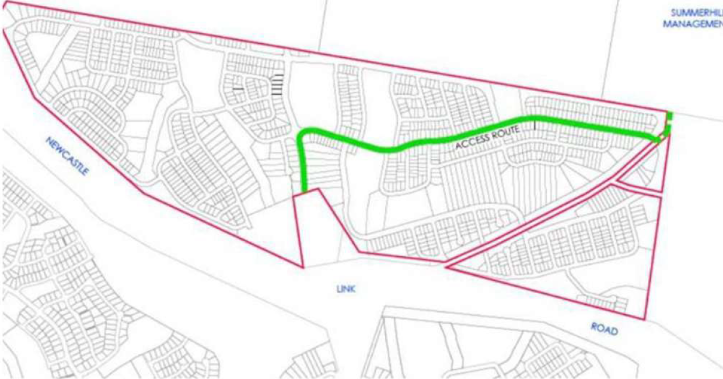
Figure 10: Proposed waste removal vehicle route
Council concur with the applicant’s interpretation of the condition and the condition relates to typical garbage trucks which can move through the subdivision. The collector road network, which also is a bus route, provides for waste removal vehicles. Civil engineering plans have been submitted which demonstrate the internal road network can cater for waste servicing vehicles.
Insufficient information has been provided to demonstrate the connection of MC58 to the boundary of the site and SWMC. The subdivision plans adjacent to Lots 2632-2634 do not demonstrate how the future connection will be achieved. It is understood this is a resolvable matter following the submission of additional concept plans. The application is recommended to be deferred to enable the submission of further information to address this.
The relevant Council is interpreted to apply to the Council of which the land is located within, being LMCC in this instance.
4.10.3 Southern access to SWMC
Objections have been received from CN regarding the impact of the development to a future southern access road for light and heavy vehicles, within the unformed road corridor, which will provide an opportunity for a new entry/exit to the facility.
The road corridor is located within the LMCC LGA and is currently not formed. The corridor comprises the road reserved owned by LMCC, and TfNSW land. Forming of the roadway through an appropriate planning pathway and assessment, could provide vehicle access to the southern boundary of SWMC.
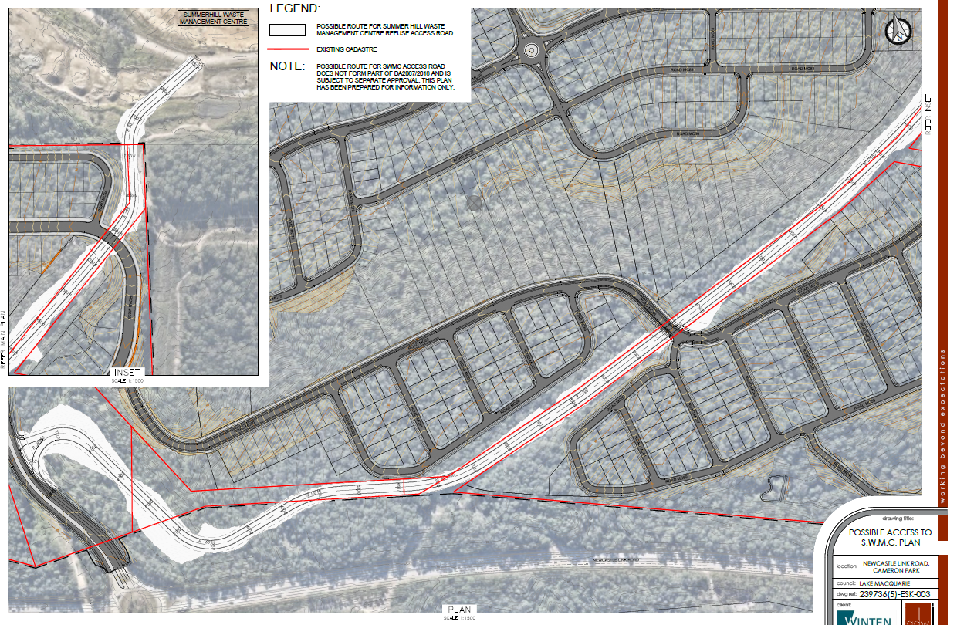
Figure 11: Indicative southern access to SWMC
The application has demonstrated a future southern access road to SWMC within the unformed LMCC road corridor will not be compromised by the development. The development provides a public reserve buffer to the road corridor. The roads within the subdivision that intersect with the road corridor, have been designed to go underneath any future access road, with an access road designed and constructed to be grade separated above. Environmental impacts, such as acoustic, visual, etc, would be considered during the planning assessment of the access road, which is likely to be a Part 5 assessment.
4.11 Traffic impact
4.11.1 Access and road network
Access to the development is provided by a new connection to the existing roundabout on Newcastle Link Road. Northern access is proposed via two connections to the proposed subdivision development in CN, which both provide connection to Woodford Street.
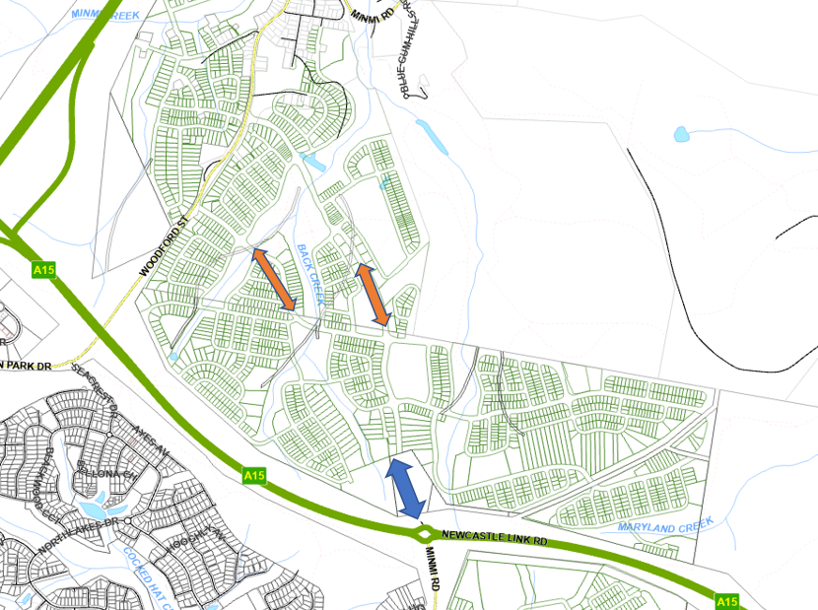
Figure 12: Access locations to development
(Link Road access shown in blue and northern access shown in orange)
Lots within the development will be accessed via the internal road network. No direct access from residential lots is proposed to the Newcastle Link Road, or the proposed boulevard on the internal road network (Minmi Boulevarde).
Condition 1.32 of the Concept Approval requires all aspects of the local road layout and design meet the requirements of the relevant Council.
Civil engineering plans have been submitted with the application, which demonstrate a logical hierarchy for the road system, with local and collector roads in a modified grid layout proposed. The road grades, carriageway widths, intersection locations and configuration is consistent with Council’s requirements.
The application proposes a signalised intersection adjacent to the school site (Lot 2046) and commercial zoned land. Civil engineering plans demonstrating the intersection design has been submitted. The design will require minor adjustment to several of the lots adjoining the intersection. Revised subdivision lot plans to account for the intersection design have not been submitted.
A request for this information has not been made to the applicant due to the outstanding fundamental site planning and threshold issues. A request for this information can made following the resolution of these fundamental issues, as it is likely the development can achieve this requirement through submission of further information.
It is recommended the application be deferred to enable the submission of further information to address this matter.
4.11.2 Public transport
The internal road network has been designed to accommodate a bus route throughout the estate. Two options are proposed as a collector route, as demonstrated in Figure 13.
Consultation has been undertaken with the bus service provider (Hunter Valley Buses) and TfNSW. TfNSW are supportive of either of the two options proposed
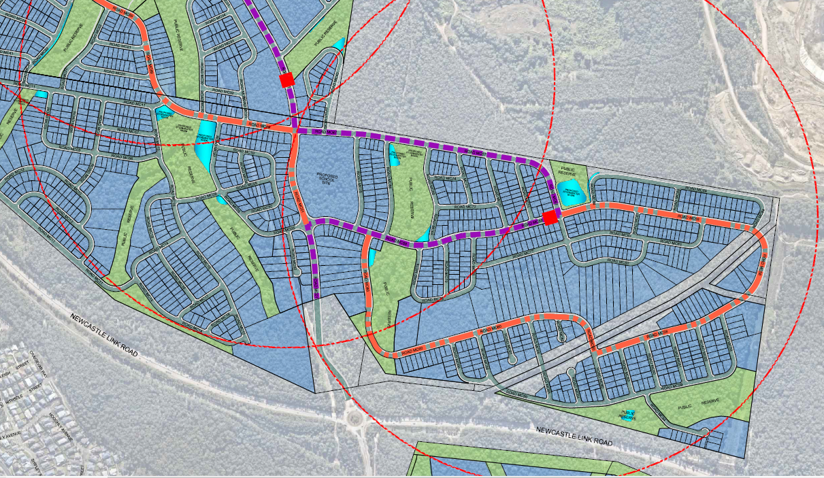
Figure 13: Bus route options
4.11.3 Pedestrian and cycle facilities
Pedestrian and cycle paths are incorporated throughout the subdivision and provide internal connectivity, as well as connections to BGHRP and other stages of the development.
These facilities have been incorporated into the road reserve widths demonstrated on the subdivision plans.
4.11.4 Concept Approval condition 1.31
Condition 1.31 of the Concept Approval requires the first development application for subdivision within each stage to include a revised traffic and transport impact assessment prepared in consultation with TfNSW and the relevant council(s). Each traffic assessment must include:
- Details of traffic generation and distribution from all land uses proposed within that stage including retail, sporting facilities and education facilities
- Intersection analysis and micro-simulation modelling to determine the impact of the proposal on the existing regional and local road network
- Proposed timing for upgrades of key intersections, in particular Newcastle Link Road / Woodford Street / Cameron Park Road and Newcastle Link Road / Minmi Road in accordance with RMS requirements
- Details of any proposed upgrades to the road network, including timing and funding arrangements, to accommodate the proposed development. This is to include identification of suitable pedestrian links across Minmi Road and Newcastle Link Road
A regional traffic and transport assessment and traffic impact assessment have been submitted with the application. The reports have undertaken microsimulation modelling that assesses the impact of the development’s traffic at years 2026, 2031 and 2036, and proposed road and intersection upgrades, staged as required, to be implemented to ensure the road network will operate at a satisfactory level of service during, and at the completion of, the development.
The modelling identifies the following upgrades are required:
- upgrade from roundabout to signalised intersection of Newcastle Link Road / Minmi Road
- widening of Minmi Road from Newcastle Link Road to Transfield Avenue from two to four lanes
- installation of new roundabout at Minmi Road / Transfield Avenue
- widening from two lanes to four lanes of Minmi Road from Transfield Avenue to Sedgwick Avenue
- installation of additional turning lanes to Newcastle Link Road / Woodford Street
- line marking changes to Minmi Road / Northlakes Drive
- upgrade to Minmi Road / Main Road intersection to replace parking lane with traffic lane and link marking changes
- upgrade Newcastle Link Road / Lake Road signalised intersection
The application proposes that some of the works are to be delivered by the developer, with others to be delivered by TfNSW and LMCC. TfNSW and LMCC have not confirmed they will deliver the upgrades allocated to them as identified by the applicant.
The application was referred to TfNSW on several occasions for consideration of traffic impacts. TfNSW initially identified they are supportive of the extensive upgrades originally proposed, however it is understood the Panel have sought advice and there is no nexus and power for the Panel to impose the upgrade requirements upon the development. The applicant has submitted revised documentation outlining a reduced scale of works, and implementation of staging, which TfNSW remain unsatisfied. It is understood the key concern of TfNSW relates to insufficient modelling being completed, and therefore the impact of the development and upgrading works to mitigate the impact associated with the development cannot be identified. This matter remains unresolved.
The applicant proposes the road upgrades to be conditioned via a Grampian condition. It is understood the Panel have sought legal advice regarding this matter and will determine the legal ability to impose a Grampian condition for the application.
Should a Grampian condition be supported, it is recommended the application be deferred to enable the submission of further modelling.
4.11.5 Statement of commitments
The statement of commitments also requires traffic studies being updated prior to commencement of each stage of development to reflect actual traffic yields, upgrades to intersection with collector roads as required by TfNSW/LMCC/CN, implementation of local traffic management measures where required, provision of bus stops, shelters and pedestrian refuges, provision of appropriate acoustic measures as agree with LMCC / CN, constructed and embellished of areas to be dedicated to council in accordance with the specifications of the Concept Plan and construction specifications of the appropriate Council.
These matters can be addressed through the imposition of an appropriate condition of consent.
The statement of commitments also requires CPTED principles to be addressed for each development application. The design and layout of the subdivision provides for casual surveillance throughout lot and road layout, and space management through appropriate landscaping of public assets. Access control, territorial reinforcement and space management will be achieved through the future residential development of the land where fencing, landscaping and access will be provided to individual lots.
4.11.6 Transport and Infrastructure SEPP
Clause 2.122 - traffic-generating development of the Transport and Infrastructure SEPP, requires subdivision application with 200 of more residential lots to be sent to TfNSW.
A referral has sent to TfNSW, in conjunction with the referral for condition 1.31 of the Concept Approval. TfNSW are not satisfied with proposal, and a response from TfNSW in respect to the SEPP has not been received.
4.12 Urban design
Condition 1.14 of the Concept Approval requires each application for subdivision to demonstrate lots on land with greater than 25% slope have an adequate area for a dwelling to be constructed on land which is not greater than 25% slope, and that vehicular access to the dwelling can be provided at a grade of not greater than 25%, and all lots on land with slope greater than 20% are at least 1,000m² in area. Sufficient information to enable detailed assessment of this matter has not been provided. A request for this information has not been made to the applicant due to the outstanding fundamental site planning and threshold issues. A request for this information can made following the resolution of these fundamental issues, as it is likely the development can achieve this requirement through existing site design or incorporation of measures such as retaining walls (designed and located appropriately).
Condition 1.15 of the Concept Approval requires each development application for subdivision to include a landscaping and public domain plan for the relevant stage, which demonstrates proposed open space, proposed treatments for open space and public domain, strategy for tree retention, landscaping of swales, detention basins, roadside verges and other public domain areas, management and ownership arrangements, and identification of appropriate landscaping species.
Landscaping reports and plans have been submitted demonstrating landscaping to public domain areas, including street tree planting, bioretention planting and planting of batters/embankments. Council’s Landscape Architect has reviewed the documentation and is not satisfied with the outcomes. A request for this information has not been made to the applicant (however was flagged in a request for information as a future matter to be considered) due to the outstanding fundamental site planning and threshold issues. A request for this information can made following the resolution of these fundamental issues, as landscaping outcomes are reasonable resolvable.
The statement of commitments also requires future development to be carried out generally in accordance with the UDGs. Refer to Attachment B for detailed assessment of the UDG.
The statement of commitments also requires landscape plans to be provided prior to CC demonstrating retention of existing vegetation, to the extent reasonably possible, collection of seed so indigenous species are used in landscaping of parks, and use of recycled water in public parks, if feasible. These matters have been assessed (i.e. APZs) or can be addressed through the imposition of an appropriate condition of consent.

4.13 Utilities and servicing
Clause 6.2 and 7.21 of LM LEP require public utility infrastructure and essential services to be provided to the development (or made available).
The statement of commitments also requires water and sewer, underground power and NBN conduits to be provided.
The development includes the following utility and servicing infrastructure works:
- Water and sewer
- Electrical infrastructure
- Gas infrastructure
- Communications (i.e. NBN)
- Road / intersection upgrades
Within the subdivision, utility services including water, sewer (including wastewater pump stations and rising mains), electrical infrastructure (including underground power, kiosks), gas, and telecommunications will be installed and connected to each residential lot. Utilities will be located within the road reserves. Street lighting will also be installed throughout the subdivision.
4.13.1 Water and sewer
A water and sewer strategy has been provided and approved by the Hunter Water Corporation (HWC). The strategy demonstrates water and sewer is located primarily within the site.
Connection to existing reticulated networks is required and the strategy demonstrates the connection to be south west of the site. Given the works are inextricably linked to the development, further environmental assessment is required.
It is recommended the application be deferred to enable the submission of further information to address this matter, as it is resolvable.
4.13.2 Electrical infrastructure
The site is traversed by three overhead transmission lines. An easement on the eastern boundary of the site contains a TransGrid 330KV transmission line. An Ausgrid transmission line is situated within the unformed public road reserve, while the other connects via the road at Newcastle Link Road towards Minmi township.
The development will involve the relocation of the existing Ausgrid transmission line. The application was referred to Ausgrid as per clause 2.48 of the Transport and Infrastructure SEPP. Ausgrid support the proposal and have a provided a response that details the requirements for the development, which can be achieved through conditions of consent (upgrading of existing infrastructure to cater for development).
The application was referred to TransGrid as per condition 1.47 of Concept Approval. TransGrid raised no objection to the development and recommended conditions regarding construction related matters.
4.13.3 Road / intersection works
Several intersection upgrades will be required to facilitate the development. As per section 4.11.4 of this report, the extent of these upgrades is not resolved.
Should the extent of upgrades be resolved, further information will be required to consider the works required to achieve the upgrades, and the environmental impacts given these works are inextricably linked to the development.
5 CONCLUSION AND RECOMMENDATION
The application is recommended to be deferred to enable the submission of further information to address the outstanding matters as listed below.
- Concept Approval consistency
- biodiversity
- traffic impact
- earthworks
- contamination
- mine subsidence
- Summerhill Waste Management Centre impacts
- odour impact
- utilities and servicing
Alternatively, the application could be refused based upon this matter not being satisfactorily addressed.

